

HTML PROJECT

(PROPERTY-WEBSITE)

/

Prepared By :

Y a s h ( 5 5 ) & A m a n ( 4 2 )

K22RZ


ACKNOWLEDGEMENT

While I was preparing this project file, various information that I found helped me in chapter

Password security and I am glad that I was able to complete this project and understand

many things. Through preparation of this computer science project was an immense learning

experience and I inculcated many personal qualities during this process like responsibility,

punctuality, confidence and others.

I would like to thank to my teachers who supported me all the time, cleared my doubts and to

my parents who also played a big role in finalization of my project file. I am taking this

opportunity to acknowledge their support and I wish that they keep supporting me like this in

the future.

A project is a bridge between theoretical and practical learning and with this thinking I

worked on the project and made it successful due to timely support and efforts of all who

helped me.

Once again, I would like to thank my classmates and my friends also for their encouragement

and help in designing and making my project creative. I am in debt of all these. Only because

of them I was able to create my project and make it good and enjoyable experience.

04



EXECUTIVE SUMMARY

A single property website is just as it sounds —a website dedicated to a specific property that’s listed for sale. It’s a one-stop-shop where potential buyers can find everything they want to know about a home on the market, presented the way you and the seller want it to come across. Conglomeration sites like Zillow and top-down sites like MLS platforms can be difficult to navigate and don’t always follow a logical flow of information. Potential buyers can end up swiping right past a listing without even seeing its best features simply because of the way these sites are constructed and organized. With single property websites, you’re in control of what information shines through and the way that it’s organized. Understandably, many real estate professionals hear the word “website” and envision hours upon hours of coding work or expensive outsourcing for every property site. In reality, partnering with a professional service makes creating high-end real estate websites attainable and efficient.

GROW UP WITH US



SCOPE OF SERVICES

To paint that picture, include those unique details of the listing along with each of these basic aspects (they don’t all need to be listed on the homepage):

Photos of the inside of the home

Photos of the outside of the home,

including any landscaping features, pools,

and fences

A 3D Tour

Video walkthroughs Well-written descriptions to emphasize special features

Details about the surrounding area (Are there attractions or landmarks within walking distance? What’s the neighborhood like?)

Key specs like square footage, lot size, and property history

GROW UP WITH US



SCOPE OF SERVICES

In deciding what specific details to include in a property website, think through the qualities that make the home special. People don’t seek out luxury real estate because they want to blend in with the status quo. What makes the property unique? What’s different about it? How would it feel to live there?

Appeal to potential buyers’ emotions as you curate your descriptions and photos. Allow the website to become a storytelling platform. Anyone visiting the site should be able to picture themselves living in the home once they’ve browsed the blurbs and images. How do they feel? Does the house scream innovation and edginess, or is it a peaceful oasis? Is it a classic spot for hosting or an escape? Paint a picture that appeals to what your ideal buyer is seeking in their next home in a way that is true to the home itself.

GROW UP WITH US

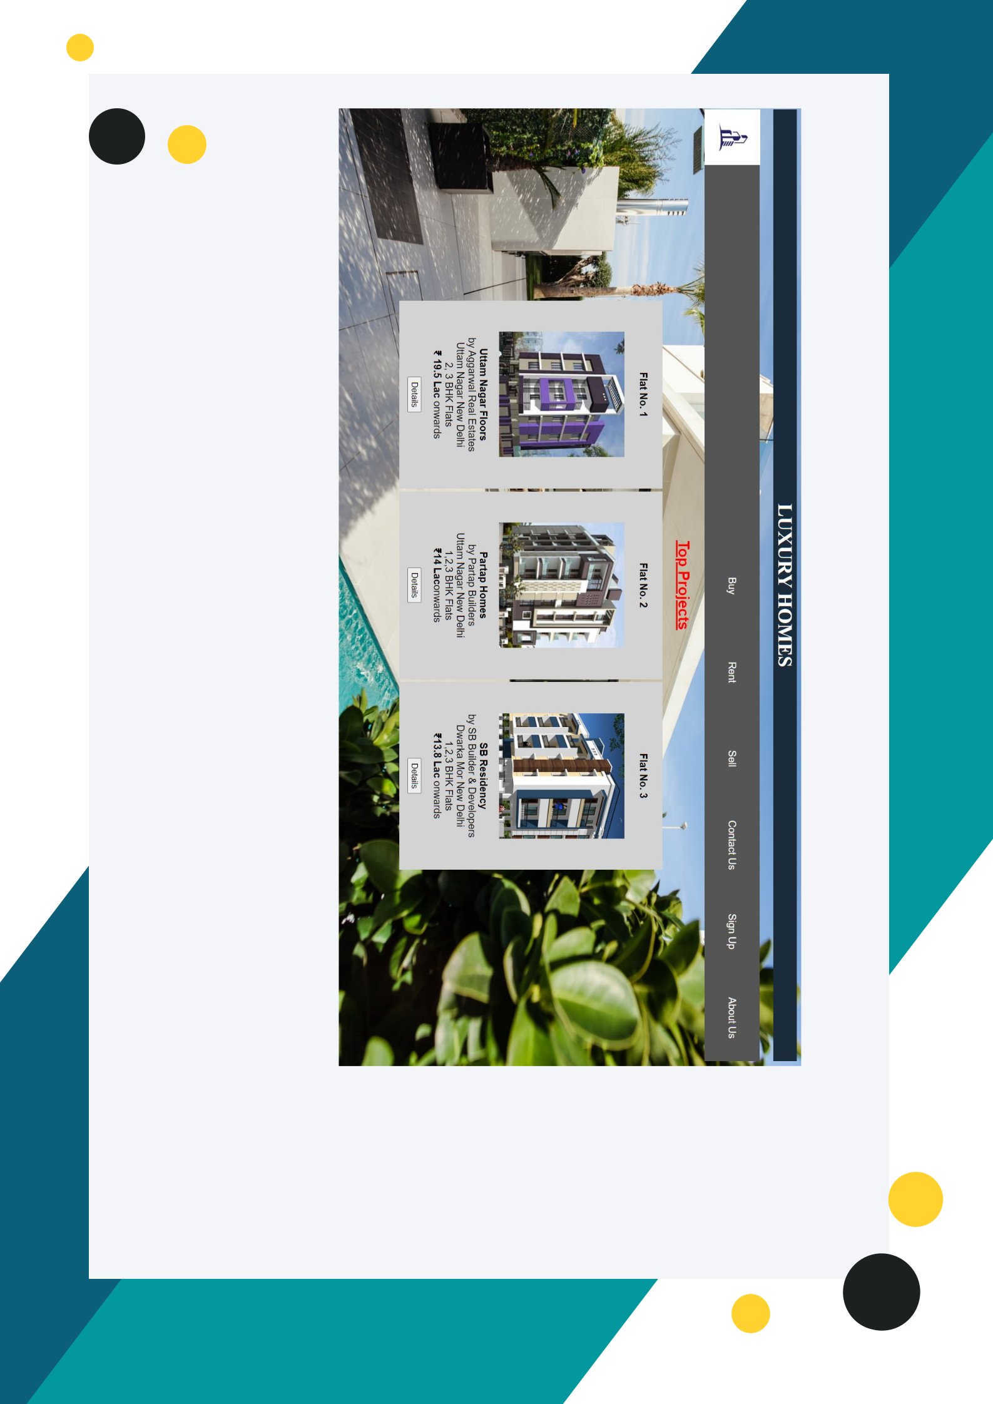

DEMO:-

GROW UP WITH US



LANGUAGES USED:-

The HyperText Markup Language or HTML is the standard markup language for documents designed to be displayed in a web browser. It can be assisted by technologies such as Cascading Style Sheets (CSS) and scripting languages such as JavaScript.

Web browsers receive HTML documents from a web server or from local storage and render the documents into multimedia web pages. HTML describes the structure of a web page semantically and originally included cues for the appearance of the document.

GROW UP WITH US



LANGUAGES USED:-

HTML documents imply a structure of nested HTML elements. These are indicated in the document by HTML tags, enclosed in angle brackets thus: <p>.[71] [better source needed]

In the simple, general case, the extent of an element is

indicated by a pair of tags: a "start tag" <p> and "end

tag" </p>. The text content of the element, if any, is

placed between these tags

Headings

HTML headings are defined with the <h1> to <h6> tags

with H1 being the highest (or most important) level

and H6 the least:

Line breaks:

<br />. The difference between <br /> and <p> is that <br /> breaks a line without altering the semantic structure of the page, whereas <p> sections the page into paragraphs. The element <br /> is an empty element in that, although it may have attributes, it can take no content and it may not have an end tag.

GROW UP WITH US



LANGUAGES USED:-

Attributes

Main article: HTML attribute

Most of the attributes of an element are name–value pairs, separated by = and written within the start tag of an element after the element's name. The value may be enclosed in single or double quotes, although values consisting of certain characters can be left unquoted in HTML (but not XHTML).[73][74] Leaving attribute values unquoted is considered unsafe.[75] In contrast with name-value pair attributes, there are some attributes that affect the element simply by their presence in the start tag of the element,[6] like the ismap attribute for the img element.[

Data types

HTML defines several data types for element content, such as script data and stylesheet data, and a plethora of types for attribute values, including IDs, names, URIs, numbers, units of length, languages, media descriptors, colors, character encodings, dates and times, and so on. All of these data types are specializations of character data.

GROW UP WITH US



LANGUAGES USED:-

Cascading Style Sheets (CSS) is a style sheet language used for describing the presentation of a document written in a markup language such as HTML or XML (including XML dialects such as SVG, MathML or XHTML).[1] CSS is a cornerstone technology of the World Wide Web, alongside HTML and JavaScript.[2] Syntax[edit]

CSS has a simple syntax and uses a number of English keywords to specify the names of various style properties.

CSS IS DESIGNED TO ENABLE THE SEPARATION OF CONTENT AND PRESENTATION, INCLUDING LAYOUT,

COLORS, AND FONTS.[3] THIS SEPARATION CAN IMPROVE CONTENT ACCESSIBILITY; PROVIDE MORE FLEXIBILITY

AND CONTROL IN THE SPECIFICATION OF PRESENTATION

CHARACTERISTICS; ENABLE MULTIPLE WEB PAGES TO SHARE FORMATTING BY SPECIFYING THE RELEVANT CSS IN A SEPARATE .CSS FILE, WHICH REDUCES COMPLEXITY AND REPETITION IN THE STRUCTURAL CONTENT; AND

ENABLE THE .CSS FILE TO BE CACHED TO IMPROVE THE PAGE LOAD SPEED BETWEEN THE PAGES THAT SHARE THE FILE AND ITS FORMATTING.

GROW UP WITH US


DEMO:
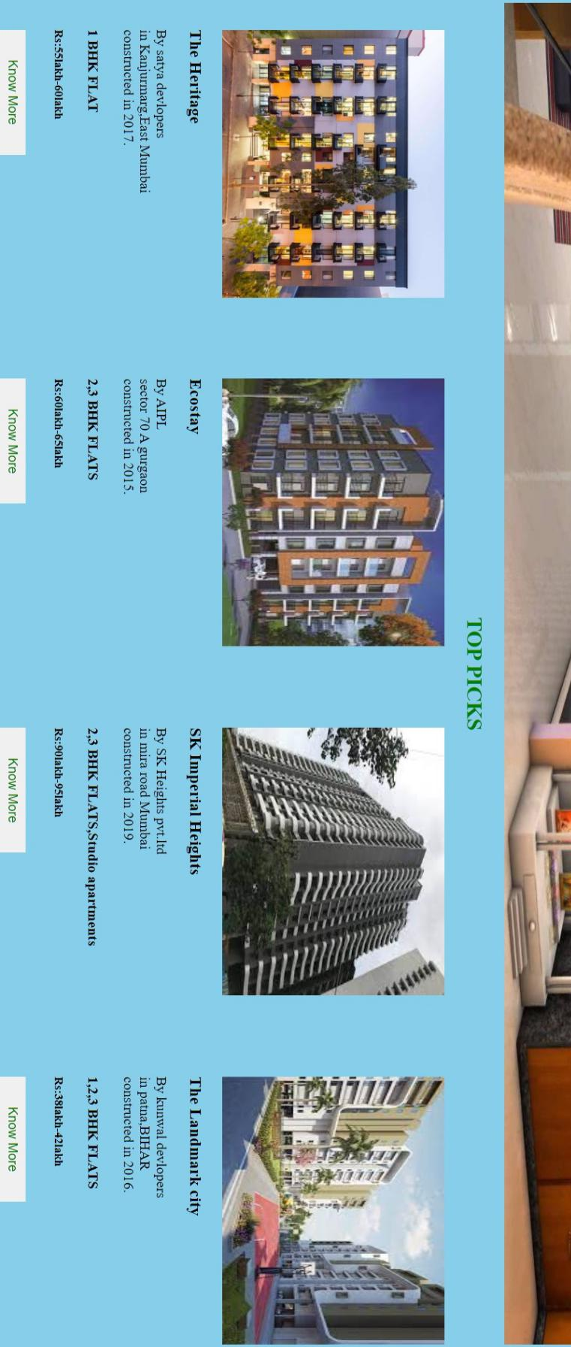
DEMO:
